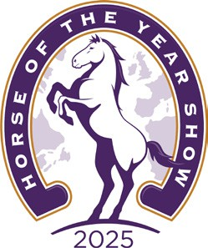 



HOYS 2025

Pony Club Mounted Game Team Manager Order Form

Pony Club Branch.............................. Team Manager Name......................................

Please circle the appropriate size

|  |  |  |
| --- | --- | --- |
| ITEM | SIZE | QUANTITY |
| Soft Shell Jacket | 6 | You will receive 1 soft shell jacket. If there isn’t a size suitable, please contact Annabel Stanley |
| 8 |
| 10 |
| 12 |
| 14 |
| Soft Shell jacket Equivalent Men’s Size |  |  |

This is the team’s kit list that LeMieux are supplying.

Please note, if you require men’s clothing, please write the equivalent size required.

The **deadline** to return this form is **two weeks** post qualifying date unless otherwise stated.

For all questions, please contact Annabel Stanley - [mountedgames@pcuk.org](mailto:mountedgames@pcuk.org)